Chapter 12, Solution 9.

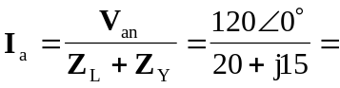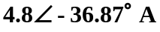

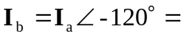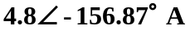

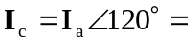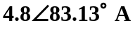

As a balanced system, 